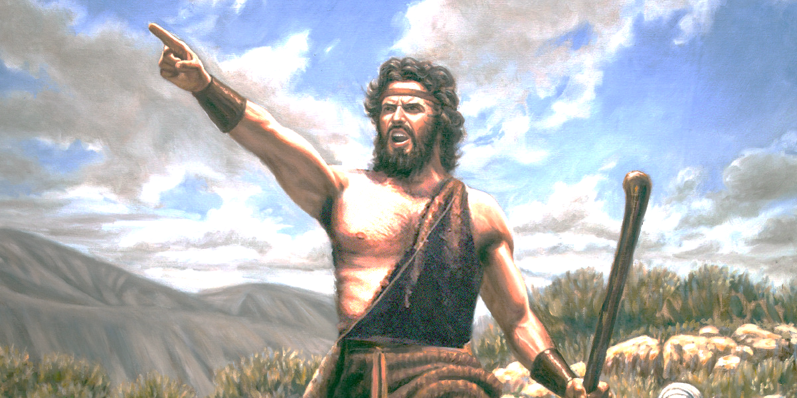
The message of John the Baptist

Matthew 3:1-12
1) John came peaching about repentance – Matthew 3:1-7
- Repentance is changing the way you think – 2 Corinthians 10:4-5
- Repentance is contrition, or feeling bad about sin – Acts 2:36-39,
- True repentance results in a change of lifestyle - 2 Corinthians 7:10-11
- True repentance cause one to acknowledge and confess their sins – Acts 19:18-20
- Repentance brings refreshing – Acts 3:19

2) Bring forth fruits worthy of repentance – Matthew 3:7-10
If you were on trial for being a Christian, would there be enough evidence to convict you?
- So when they had brought their boats to land, they forsook all and followed Him. Luke 5:11
- Matthew left all and followed Jesus - Luke 5:27-32

3) Jesus wants to baptize you in the Holy Spirit and fire – Matthew 3:11-12
- Fire purifies – Malachi 3:2-3
- Fire illuminates – Psalm 119:105
- Fire energizes – Romans 12:11

