Fire Fall
Therefore, since we are receiving a kingdom which cannot be shaken, let us have grace, by which we may serve God acceptably with reverence and godly fear. For our God is a consuming fire. Hebrews 12:28-29

1) Fire is an emblem of the Holy Spirit - Matthew 3:11-12
- Emblem - a thing serving as a symbolic representation of a particular quality or concept.
- Fire is energy (fervency), illumination (Psalm 119:105) and purification (Malachi 3:2-3)
- Other emblems representing the Holy Spirit are the dove (Luke 3:21-22), water (Isaiah 44:3) and wind (Acts 2:1, John 3:8)

2) Fire is fervency within
- Fervent – Hot, burning, or glowing. Having or displaying a passionate intensity.
- Not lagging in diligence, fervent in spirit, serving the Lord. Romans 12:11
- Never lag in zeal and in earnest endeavor; be aglow and burning with the Spirit, serving the Lord. Romans 12:11
- Acts 18:24-25 - Apollos was a complete man, both brilliant and fervent. The opposite would be stoic, cold, and unemotional.

3) How is fervency expressed?
- Fervency in love – 1 Peter 1:22
- Fervency in witness: He vigorously refuted the Jews – Acts 18:28
- Fervency in praise: Psalm 149:5-6, 2 Chronicles 5:13-14, 7:1-3, 2 Samuel 6:14-23
- Fervency in prayer: Colossians 4:2, James 5:16, Acts 4:23-31
- The earnest (heartfelt, continued) prayer of a righteous man makes tremendous power available [dynamic in its working]. James 5:16b

4) Stir up the flames
2 Timothy 1:6, Hebrews 1:7
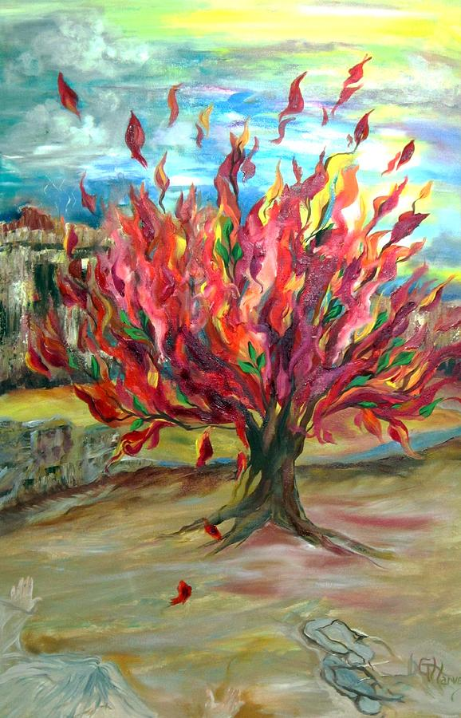
- That is why I would remind you to stir up (rekindle the embers of, fan the flame of, and keep burning) the [gracious] gift of God, [the inner fire] that is in you by means of the laying on of my hands [with those of the elders at your ordination]. 2 Timothy 1:6 AMPC

