The Name of Jesus
Your hand-to-hand combat is not with human beings, but with the highest principalities and authorities operating in rebellion under the heavenly realms. For they are a powerful class of demon-gods and evil spirits that hold this dark world in bondage. Ephesians 6:12 TPT

You are in an epic spiritual war. You must know your authority in Christ. To win a spiritual battle, you must use spiritual weapons. You and I have been given the powerful name of Jesus. At that name demons tremble. At that name, every knee will bow and every tongue will confess that Jesus is Lord (Philippians 2:9-11)

1) All things are under your feet - Ephesians 1:15-23
For if by the one man's offense death reigned through the one, much more those who receive abundance of grace and of the gift of righteousness will reign in life through the One, Jesus Christ. Romans 5:17

2) The power of the name of Jesus
The name of the Lord is a strong tower; The righteous run to it and are safe. Proverbs 18:10
- Power of attorney – The authority to act on behalf of another person. The name of Jesus is our power of attorney. When we act in the name of Jesus, we are acting in his authority.
- Power in prayer – John 14:12-17, John 16:23-24
- Power over demons – Luke 10:17-20, Acts 16:16-18
- Power over sickness and disease - Acts 3:6, 16, Matthew 10:1, 7-8
- Power to be saved by that name – Acts 4:5-12

3) To have authority, you must be under authority
James 4:6-10, Acts 19:11-20

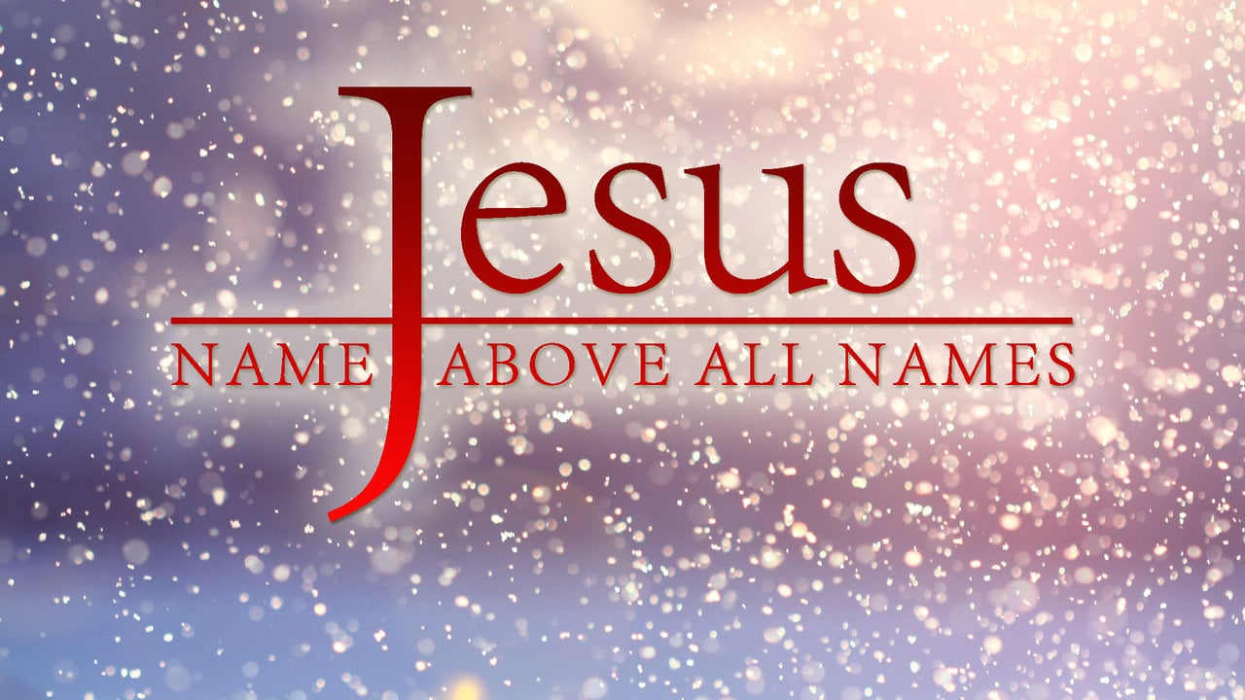
For there is no distinction between Jew and Greek, for the same Lord over all is rich to all who call upon Him. For “whoever calls on the name of the Lord shall be saved.”
Romans 10:12-13

the names of Jesus
For unto us a Child is born, unto us a Son is given; And the government will be upon His shoulder. And His name will be called Wonderful, Counselor, Mighty God, Everlasting Father, Prince of Peace. Isaiah 9:6

- Immanuel/God with us – Matthew 1:23, Isaiah 7:14
- Lamb of God – John 1:29
- Alpha and Omega – Revelation 22:13
- King of the Jews – Matthew 27:37
- Wonderful, Counselor, Mighty God, Everlasting Father, Prince of Peace – Isaiah 9:6
- The Bread of Life – John 6:35
- The Redeemer – Isaiah 59:20
- The Cornerstone – 1 Peter 2:4-8

Seven titles of Jesus in John, chapter one
- Word – 1:1-3, 14
- Light – 1:4-9
- Son of God – 1:14
- Christ – 1:19-28, 35-42
- Lamb of God – 1:29, 35-36
- King of Israel – 1:43-49
- Son of Man – 1:50-51

There are 198 names and titles of Jesus in the Bible

Some names of Jesus in different languages
- Hebrew – Yeshua
- Swahili – Yesu
- Arabic – Isa
- Chinese – Yesu Jidu
- Spanish – Jesucristo

