Hidden strength
As a Christian, you have a hidden source of strength that the world does not have. You have the Spirit of God, Angels, and the Word of God. Your faith is not a crutch, or a weakness; It is a source of unlimited strength.
- Have I not commanded you? Be strong and of good courage; do not be afraid, nor be dismayed, for the Lord your God is with you wherever you go. Joshua 1:9
- That He would grant you, according to the riches of His glory, to be strengthened with might through His Spirit in the inner man. Ephesians 3:16

1) God is a hidden source of strength for His people
- Phil 4:13 -I can do all things through Christ who strengthens me
- Phil 4:13 -I have strength for all things in Christ Who empowers me [I am ready for anything and equal to anything through Him Who infuses inner strength into me; I am self-sufficient in Christ's sufficiency]. AMP
- In the day when I cried out, you answered me, and made me bold with strength in my soul. Psalms 138:3, Psalm 27:1
- The Spirit of the Lord came mightily upon Samson – Judges 14:19, 15:14, 16:5

2) David strengthened himself in the Lord - 1 Samuel 30:1-8
- When it seems you are alone, the Lord will stand with you – 2 Timothy 4:16-18
- David waited on the Lord for His strength and direction – Isaiah 40:28-41, Psalm 27:13-14
- Jonathan strengthened David in the Lord – 1 Samuel 23:16, Hebrews 10:24-25
- A prophetic word will strengthen you – Acts 15:32, 1 Timothy 1:18

3) God will send His angel to strengthen you
- Daniel 10:18-19, Matthew 4:11, Hebrews 2:14, Luke 22:43

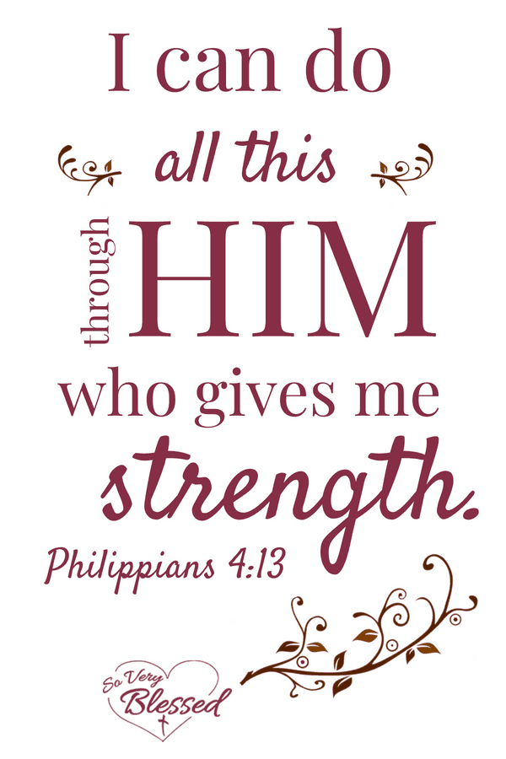
4) The wisdom of God brings strength
Ecclesiastes 7:19, 10:10, Proverbs 24:5-6, Psalm 111:10

5) The Baptism in the Holy Spirit
Acts 1:8, Jude 20

Fear not, for I am with you; be not dismayed, for I your God. I will strengthen you, yes, I will help you, I will uphold you with My righteous right hand. Isaiah 41:10

